INF 286-001 Instructor Dr. Seth Adjei
Assignment #4 Last Name: First Name:

Grade:
Comment:

Problem 1 (30%)
Write the HTML code to create an image hyperlink.
- The image is called myfamily.jpg. (5%)
- It is 200 pixels high by 300 pixels wide. (10%)
- The image should link to a web page called family.html. (10%)
- There should be no border on the image. (5%)
Suppose that the web page document that contains your image hyperlink is named as index.html. myfamily.jpg is in a folder called images. Index.html, family.html and the images folder are in the same directory, c:\MyFolder (see picture below for their directory relationship).
Note: please give the section of HTML code for the image hyperlink only (including the anchor tags and code between the anchor tags), and do not show any other parts of codes.
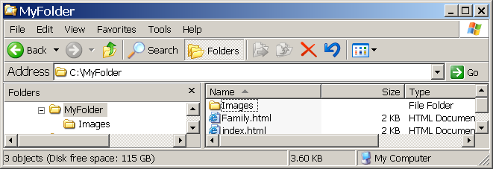

Problem 2 (30%)
- Create a file called hw42.html
- Use an embedded style to define h1, h2, and h3
- For h1 (10%):
  - use a border of size 3px, solid, color FF9900. Simple text for h1 is <h1>Here is an h1 heading</h1>
  - h1 should have padding of 5px;
- For h2 (10%):
  - use a border of size 5px, dotted and color #0033FF. Simple text for h2 is <h2>Here is an h2 heading</h2>
  - h2 should have padding of padding-top of 10px and padding-left of 5px
- For h3 (10%):
  - use a border of size 8px, dashed and color #00FFFF. Simple text for h3 is <h31>Here is an h3 heading</h3>
  - h3 should have padding of 5px for top/bottom and 20px for left/right;
- Save your file, load your file in a web browser, and paste an image of the page display result here.

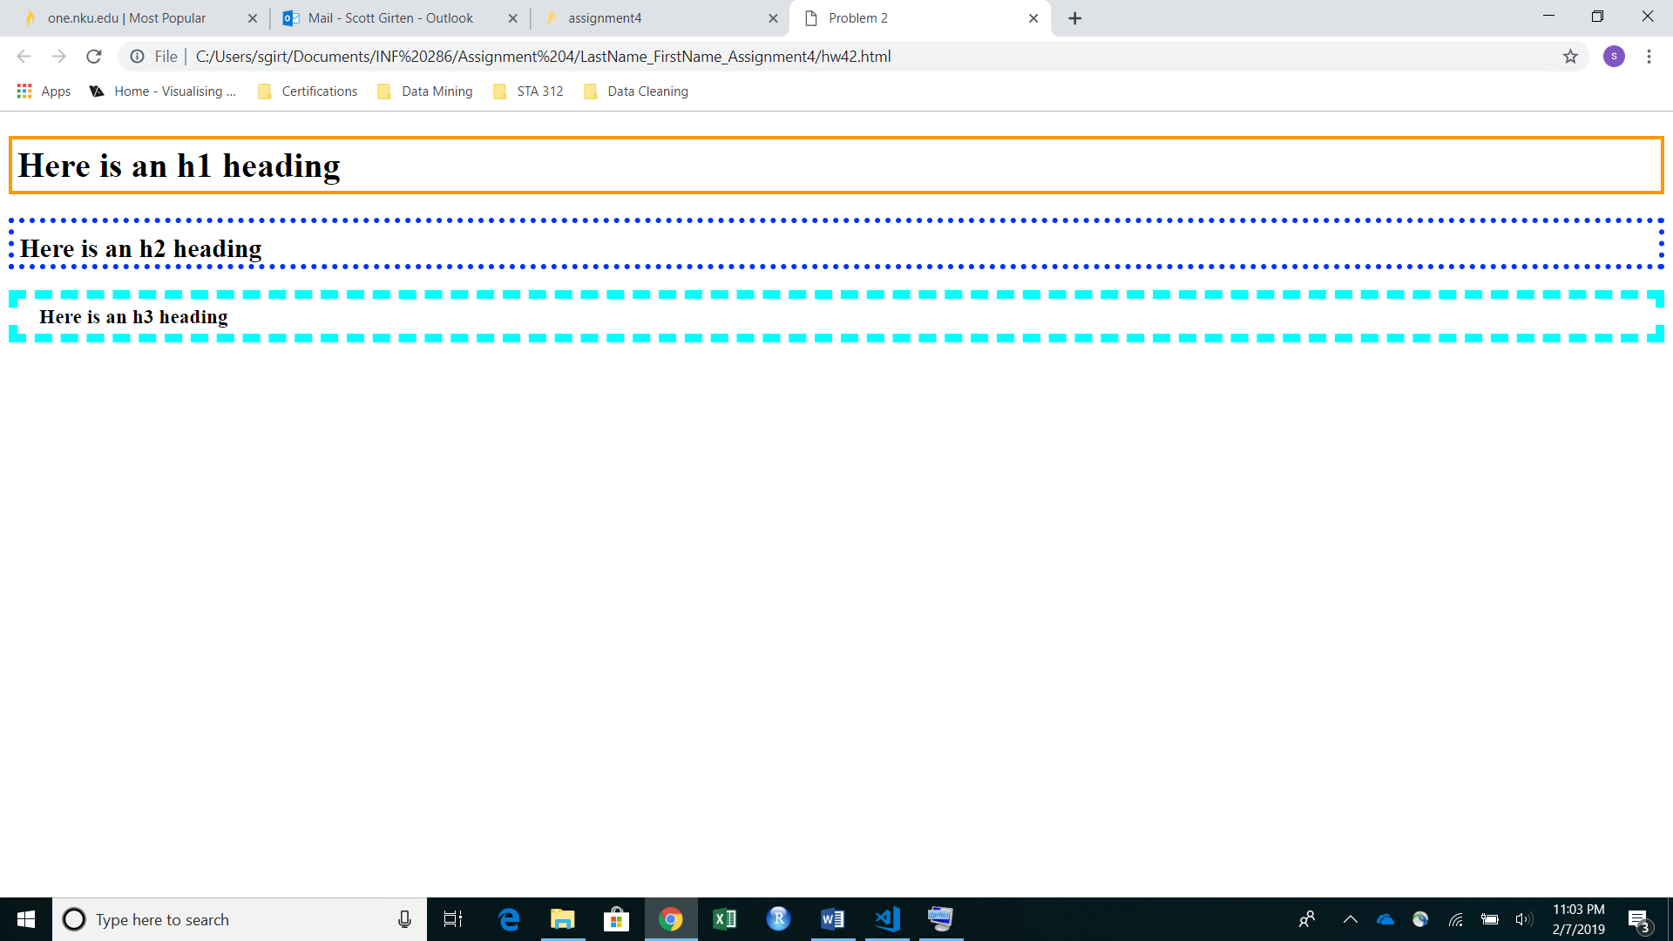
- Please also submit your code to Canvas

Problem 3 (10%)
- Save your hw42.html as hw43.html;
- Add a background image that you like to this page file so that it covers all the page background;
- Save your file, load your file in a web browser, and paste an image of the page display result here.

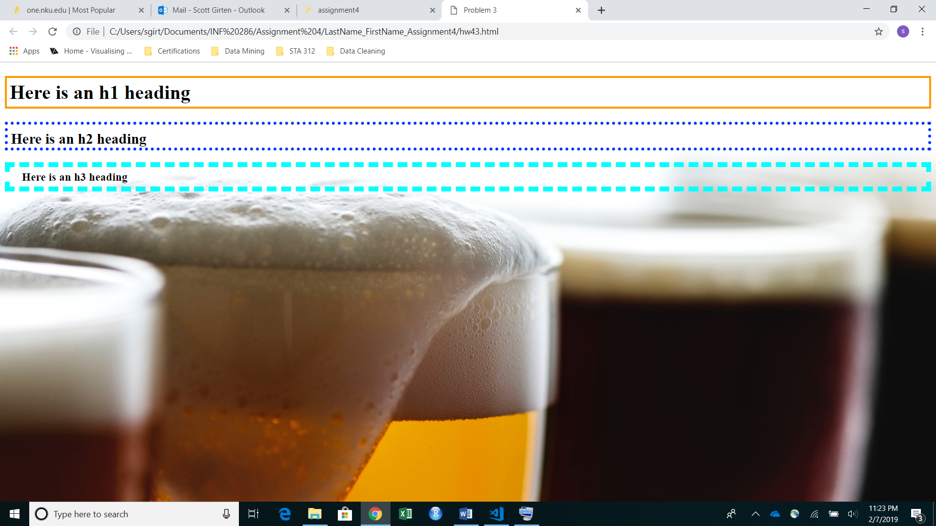
- Please also submit your code to Canvas

Problem 4 (30%)
- Add nku_logo1.gif image in a web page so that:
  - When the visitor clicks the upper half of this image, the visitor will be directed to the NKU homepage (15%);
  - When the visitor clicks the lower half of this image, the visitor will be directed to your own homepage (15%);
- Save your file as hw44.html, load your file in a web browser, and paste the page display result here.

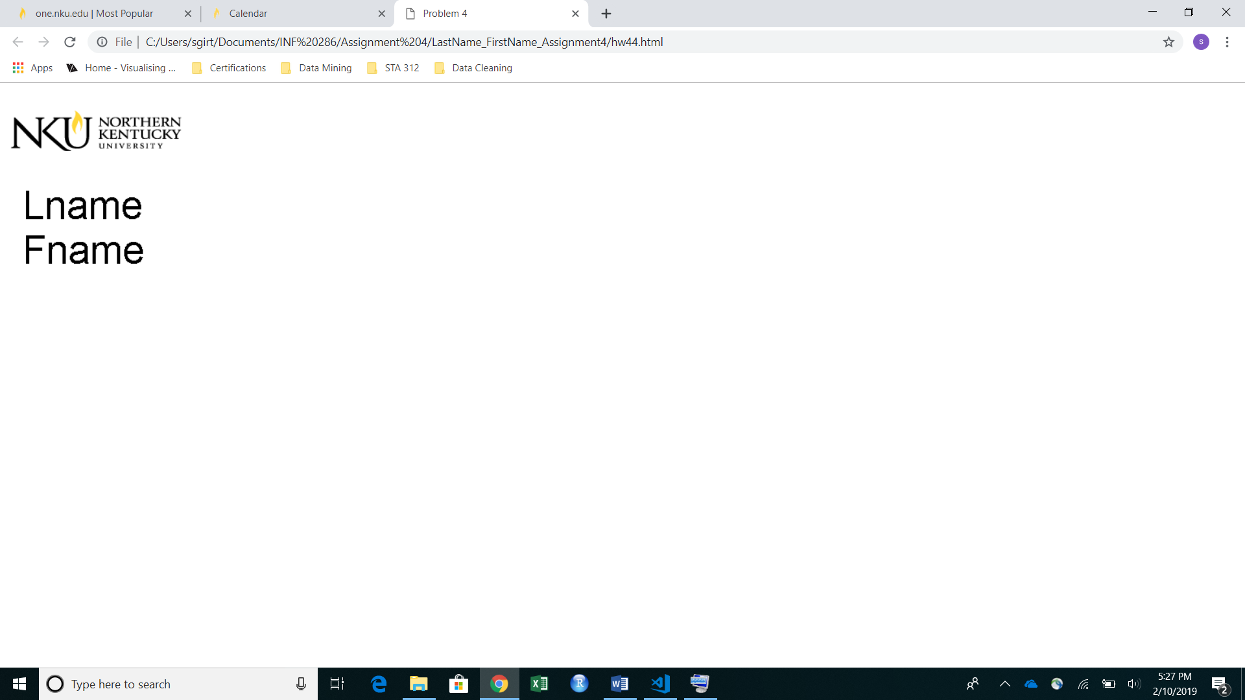
- Please submit your code to Canvas

Finally, please compress all your files including LastName_firstName_Assignment4.doc, hw42.html, hw43.html, hw44.html, and nku_logo1.gif into one zip file and rename it as LastName_firstName_Assignment4.zip, and upload this zip file to Canvas.

